UK Safety Alert

Fall from Mobile Plant

Details of the Incident
An employee suffered a fracture to his arm after falling 3 metres from his vehicle whilst attempting to descend via the emergency exit ladder. The normal means of access and egress was by a stairway with a retractable bottom section, due to mechanical problems this was not working. Investigation identified that the fault with the normal access route had been unresolved for some time and it had become normal practice to use the emergency route. The gate at the top of the emergency ladder was also faulty with the catch not properly aligned causing difficulty when releasing it. It was whilst trying to release this catch that the employee apparently fell, toppling over the gate and falling to the ground. Other factors identified were that the employee may have been carrying a plastic container at the time and would have been unable to maintain 3 points of contact.

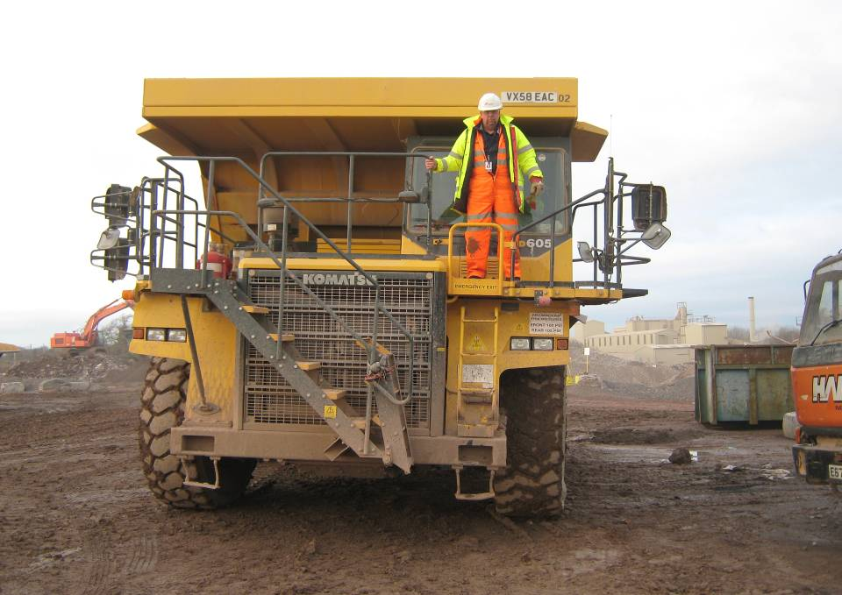 | Left Picture  Driver fell from top of emergency exit ladder  Right Picture  Close up of gate at top of emergency exit ladder | 

Learning Points
The dumper was fitted with a modern access stairway which due to a fault was out of use. Whilst alternative access was identified via the emergency exit the risks from this were not fully identified. The alternative arrangements should only have been a short term solution and in fact were allowed to persist for several months.
- Prompt maintenance – Is safety related maintenance prioritised / tracked? Are contractors / suppliers made aware of the critical nature of some jobs?
- Risk Assessment – Are alternative solutions thoroughly assessed? Does the assessment involve the people engaged in the task?
- Hazard Alert – Is everyone engaged in reporting near misses and hazards? Does everyone fully understand the need to highlight issues? Are alerts responded to with feedback to the originator in a timely manner?
- Get a Grip – Is everyone aware of the need for 3 points of contact when using steps and ladders? Is it common practice or only when being watched? Are discrete observations made to ensure that it is an ingrained behaviour?

